(Approx. 184 words)

Customizing the Quick Access Toolbar in MS Word
By Mary Phillips, Secretary, ICON, MO
May 2018 issue, THE ICON-Newsletter
www.iconusersgroup.org
Mary(at)iconusersgroup.org
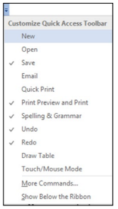
The Quick Access Toolbar in MS Word is located in the Title bar at the far-left side above the Ribbon. You can move it below the Ribbon. Initially it contains only buttons for Save, Undo, and Redo. I like to add more buttons because I use it a lot.

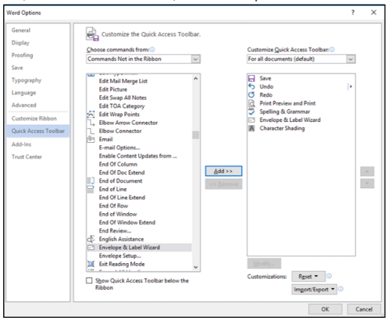
Clicking on the dropdown arrow at the right end of the QAT gives a list of the most common buttons. Checkmarks indicate which items are included. I like to add the Print Preview, Spell Check, and Envelope & Label Wizard. So, I put checkmarks beside Print Preview and Print and Spelling & Grammar. To locate the Envelope & Label Wizard button, click on More Commands, then in the Options window under

Choose commands from:
click on the dropdown arrow and select Commands Not in the Ribbon. Scroll down to
Envelope & Label Wizard, click it; click Add in the middle of the window. It should now show up in the right column. Click OK.



